**Sugamya Pustakalaya**, India is a largest online library and first, largest collection of accessible audio books for blind/print disabled. This library is your one-stop shop and remotely accesses the digital books by the visually impaired users. Sugamya Pustakalaya is a collaborative effort of TCS, Daisy Forum of India and NIEPVD (National Institute for Empowerment of Persons with Visual Disabilities), Government of India to end the book famine faced by people with print disabilities. Here, you can access books in many languages from various libraries across India. It has also partnered with international agencies like Bookshare and Accessible Books Consortium to provide you with accessible books from all over the world. Users can access a collection of over 6,53,234 audio books, maintain their individual reading shelves online and also download books in chosen formats. Sugamya Pustakalaya is a facilitating platform for producers of accessible content to jointly work in producing and providing accessible books to people with print disabilities.

**(Source** [**https://library.daisyindia.org**](https://library.daisyindia.org)**)**

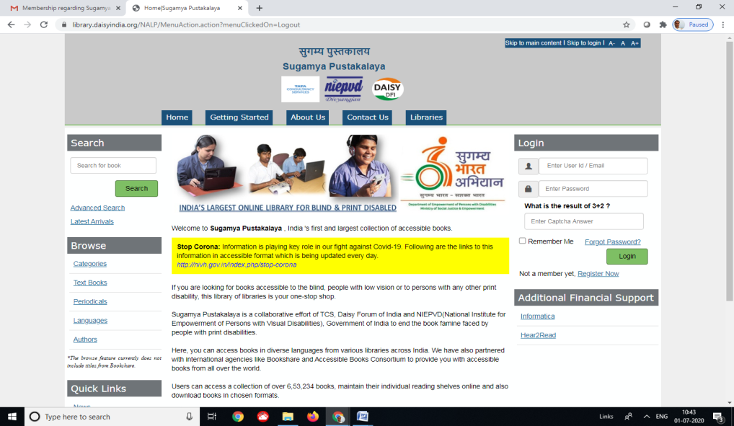

**Sugamya Pustakalaya (**[**https://library.daisyindia.org**](https://library.daisyindia.org))

Recently our library has get membership of **“Sugamya Pustakalya**” for digital and remote access digital books/e-contents in the audio format to the visually impaired users. All the visually impaired students of BHU are request to register online through Sugamya Pustakalaya Website **(https://library.daisyindia.org**) for membership and access the Sugamya Pustakalaya. Please fill up the online registration form in **End User Registration** membership option.

**End User Registration Membership Online Form**

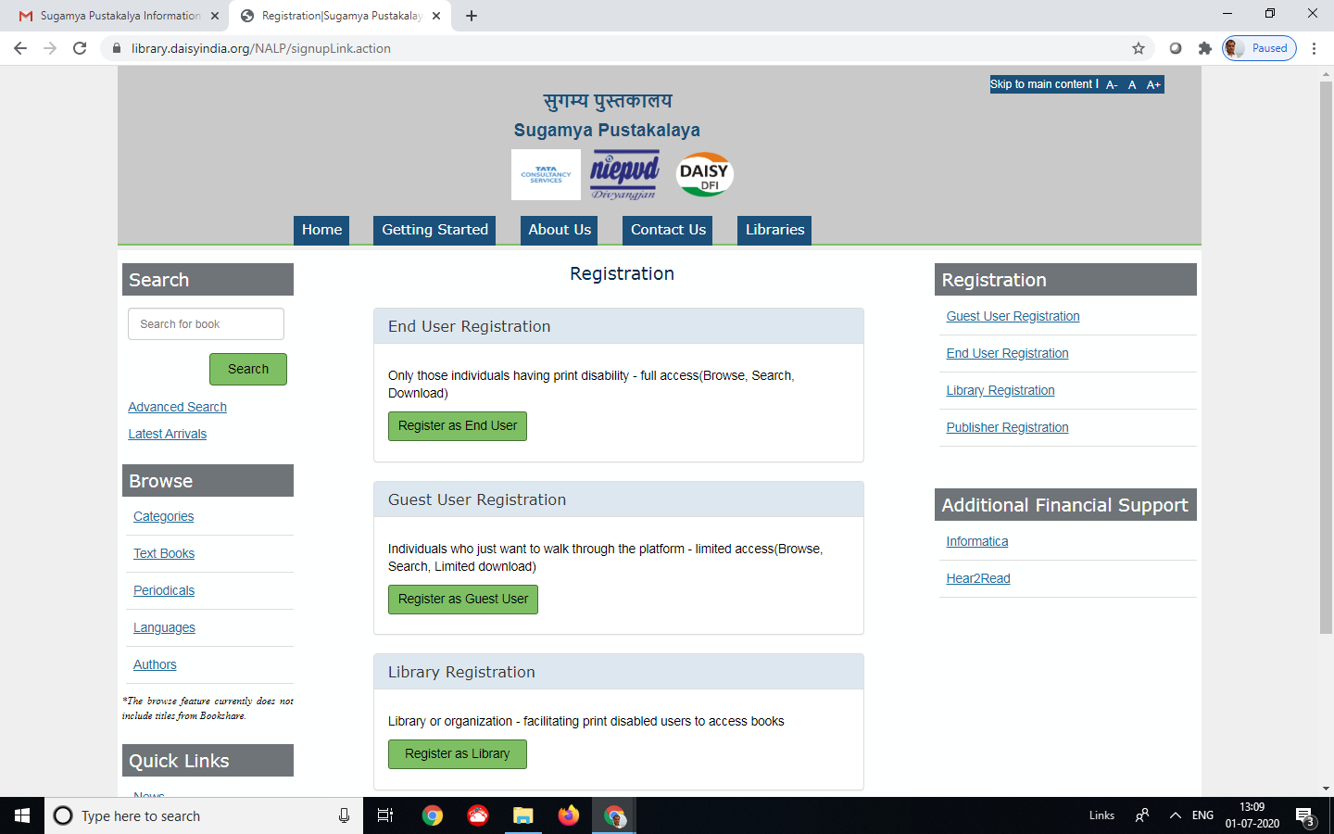

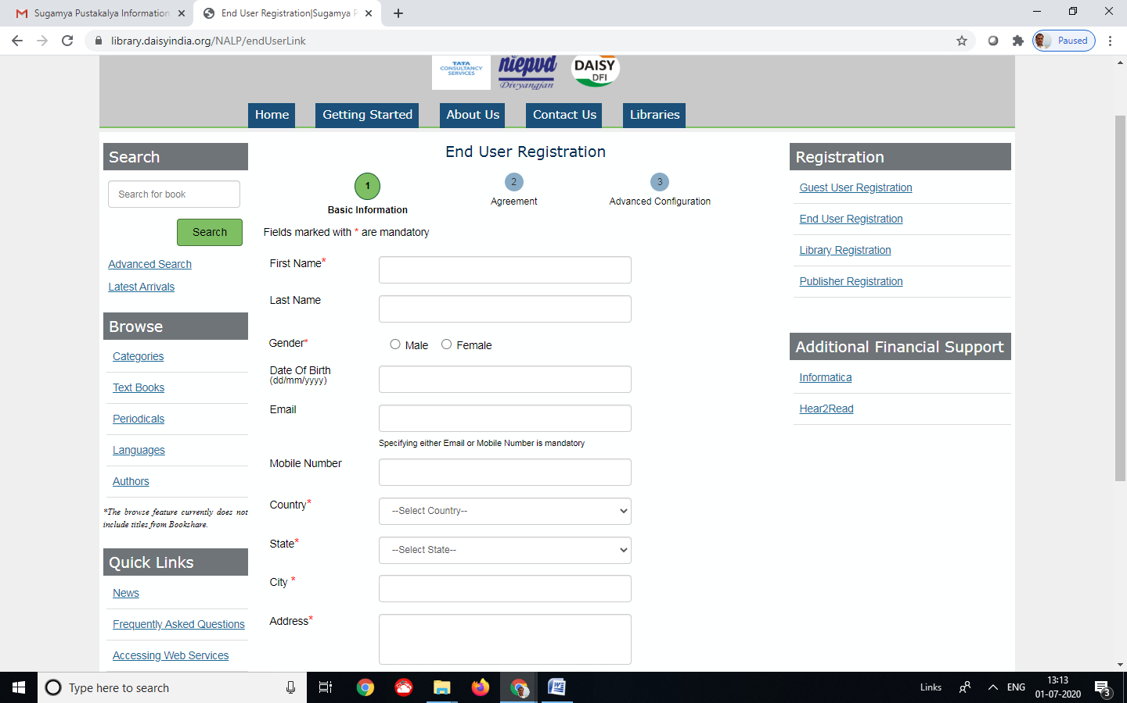

If any kindly of problem for filing the online membership registration form, please contacts the visually impaired section staff as follows.

1. Dr. Pravin Kumar Singh (Assistant Librarian) Section In-charge - 9451134245 (M)
2. Shri Ashok Kumar Shukla ( Semi Professional Assistant) - 9415818562 (M)
3. Shri Sheetala Prasad Singh (Library Attendant) - 9389774011 (M)